**PROJECT SYNOPSIS SAMPLE**

**“E-Shopping – Online shopping”**

**Submitted to the Silver Oak college of computer application**

**By**

**NAME: leuva Jay Harshbhai**

**Prajapati Tirth Maheshkumar**

**ENROLLMENT NO: 2104030100390**

**2104030100786**

In partial fulfilment of the requirements for the award of the degree of BCA

TABLE OF CONTENTS

1. Introduction

2. Objectives

3. Project category

4. Tool/ Platform hardware and software

5. Proposed System Description

6. Module Description

7. Dataflow Diagram (DFD) / E -R Diagram

8. Scope of The Project

9. Screenshots

TITLE OF PROJECT

1. Introduction: A website that allows people to buy and sell physical goods, services, and digital products over the internet rather than at a brick-and-mortar location. Through an e-commerce website, a business can process orders, accept payments, manage shipping and logistics, and provide customer services.

2. Objective: The primary objective of ecommerce site is to offer a great user experience for its customers. This means making sure that the site is easy to operate and that all features are accessible without difficulty. It also means ensuring that the website looks and feels good, both on desktop and mobile devices.

3 .PROJECT CATEGORY:

* **B2B E-commerce**
* **B2C E-commerce**
* **C2B E-commerce**
* **Marketplace E-commerce**

4. TOOLS / PLATFORM, HARDWARE AND SOFTWARE REQUIREMENT SPECIFICATION

* HARDWARE: Processor : Pentium 2.4 GHz or above
* Memory : 256 MB RAM or above
* Cache Memory : 128 KB or above
* Printer : Laser Printer
* Pen Drive : 5 GB
* FRONT END : HTML, CSS
* ACK END : SQL Server
* SCRIPTING LANGUAGE : Java Script
* WORD EDITORS : MS-WORD, NOTEPAD
* GRAPHIC TOOLS : Paint, Flash

PLATFORM

• Operating System : Windows XP(or later)

• RAM : Min 256MB

• Hard Disk Space : 40GB

• Processor : Pentium 4(or higher) or equivalent AMD

• Printer : Compatible

• Screen Resolution : 1024*768

**6. MODULE DESCRIPTION**

* **ER-Diagram**

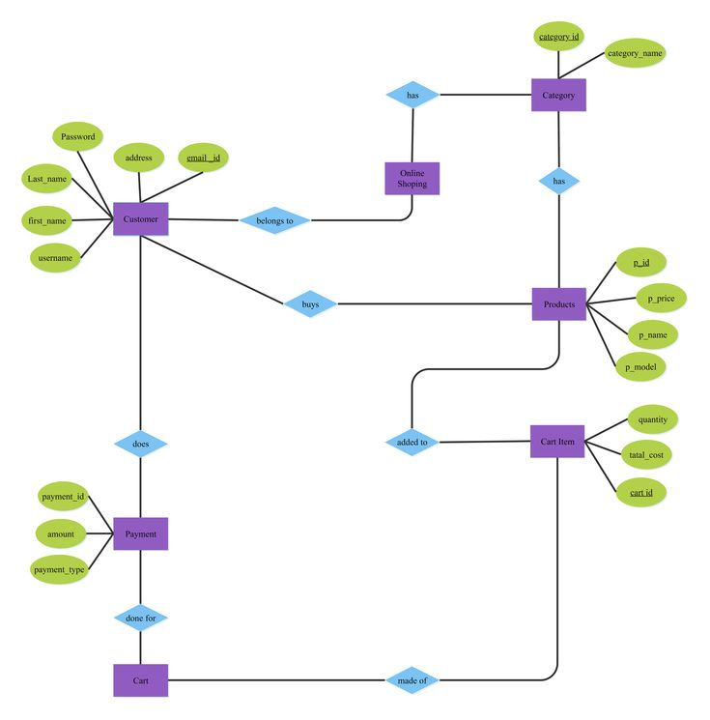

**7. DATAFLOW DIAGRAM(DFD)**

* 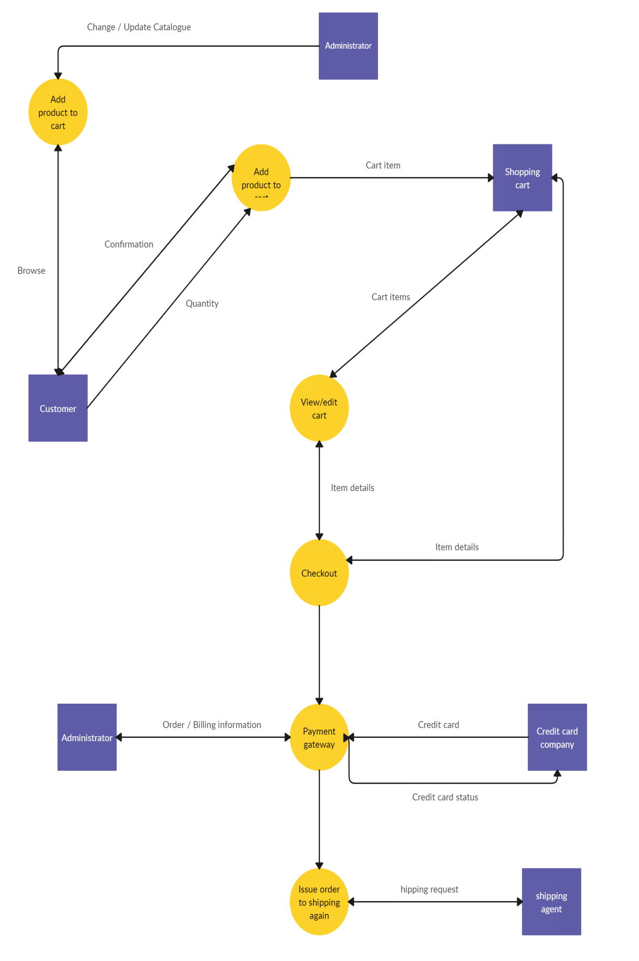**8) SCOPE OF THE PROJECT**
* So, the scope of e-commerce businesses is largely a mobile-first approach. Those that haven't made their e-stores mobile-friendly would be losing a lot of business opportunities. A big part of making your e-store website mobile-friendly is ensuring its responsiveness.

**9. screenshots of project**

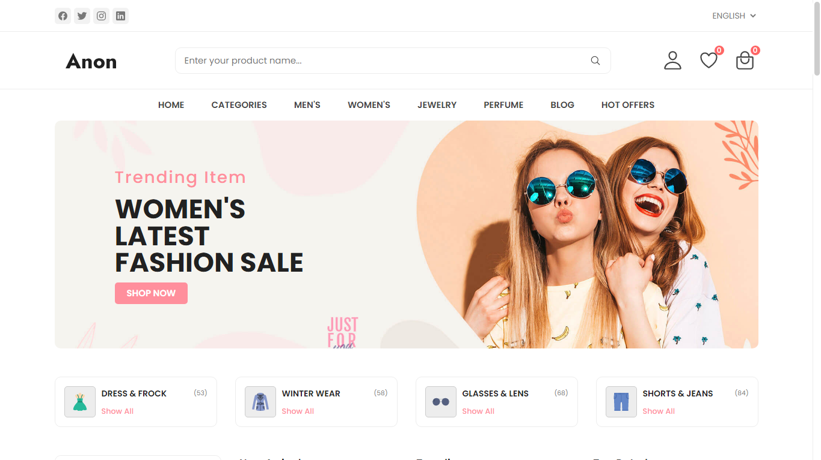

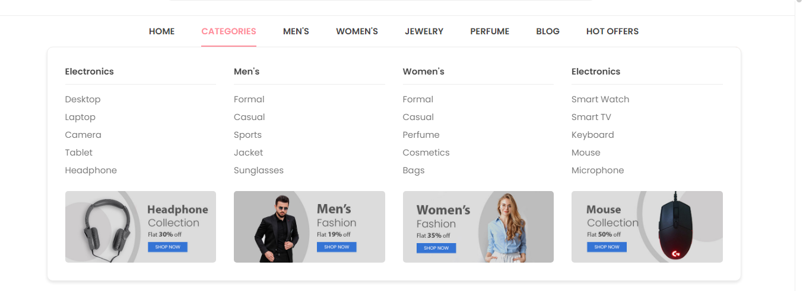

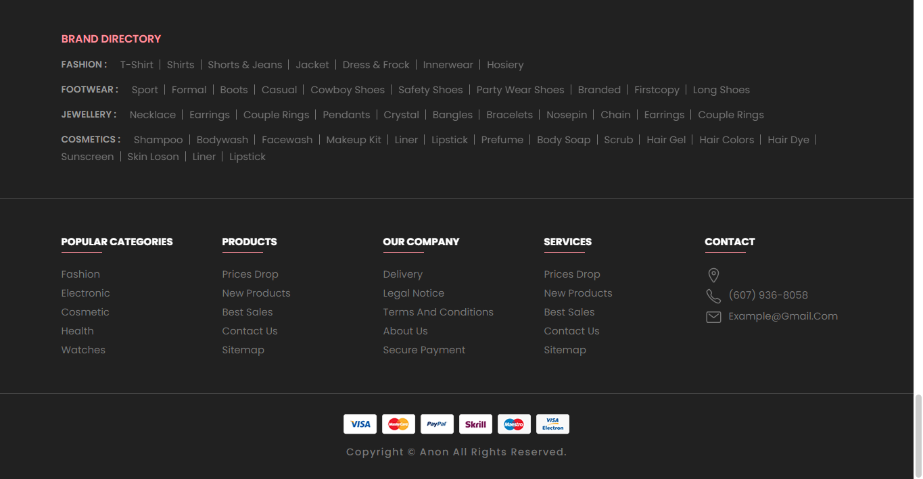

**10. FURTHER ENHANCEMENT OF THE PROJECT**